1. **Explain the types of gray level transformation used for image enhancement.**

**Image enhancement**

Enhancing an image provides better contrast and a more detailed image as compare to non enhanced image. Image enhancement has very applications. It is used to enhance medical images, images captured in remote sensing, images from satellite e.t.c

The transformation function has been given below

**s = T ( r )**

where r is the pixels of the input image

s is the pixels of the output image.

T is a transformation function that maps each value of r to each value of s

There are three basic gray level transformation.

* Linear
* Logarithmic
* Power – law

The overall graph of these transitions has been shown below.



## Linear transformation

Linear transformation includes simple identity and negative transformation.

**Identity transition:**

each value of the input image is directly mapped to each other value of output image. That results in the same input image and output image And hence is called identity transformation.

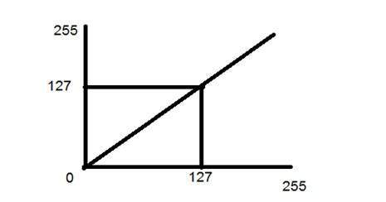

**Negative transformation**

The second linear transformation is negative transformation, which is invert of identity transformation. In negative transformation, each value of the input image is subtracted from the L-1 and mapped onto the output image.

So what happens is that, the lighter pixels become dark and the darker picture becomes light. And it results in image negative.

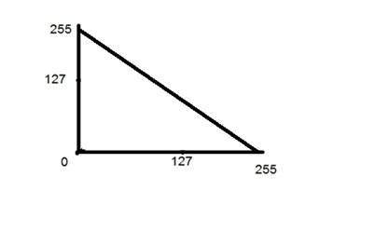

The result is somewhat like this.



**Logarithmic transformations**

Logarithmic transformation further contains two type of transformation. Log transformation and inverse log transformation.

**Log transformation**

The log transformations can be defined by this formula

s = c log (r + 1).

s is the pixel values of the output image

r is the pixel values of the input image

c is a constant.

The value 1 is added to each of the pixel value of the input image because if there is a pixel intensity of 0 in the image, then log (0) is equal to infinity.

So 1 is added, to make the minimum value at least 1.

During log transformation, the dark pixels in an image are expanded as compare to the higher pixel values.

The higher pixel values are kind of compressed in log transformation. This result in following image enhancement.

The value of c in the log transform adjusts the kind of enhancement you are looking for.

**The inverse log transform is opposite to log transform.**



## Power – Law transformations

There are further two transformation is power law transformations, that include nth power and nth root transformation. These transformations can be given by the expression:

**S = cr ^ γ**

**This symbol γ is called gamma,** due to which this transformation is also known as gamma transformation.

Variation in the value of γ varies the enhancement of the images. Different display devices / monitors have their own gamma correction, that’s why they display their image at different intensity.

This type of transformation is used for enhancing images for different type of display devices. The gamma of different display devices is different. For example Gamma of CRT lies in between of 1.8 to 2.5, that means the image displayed on CRT is dark.

### Correcting gamma.

s=cr^γ

s=cr^(1/2.5)

1. **Discuss the concept of Correlation and Convolution in linear spatial filtering with an example**

# **Correlation vs Convolution Filtering**

Filtering an image is replacing each pixel with a linear combination of its neighbors.

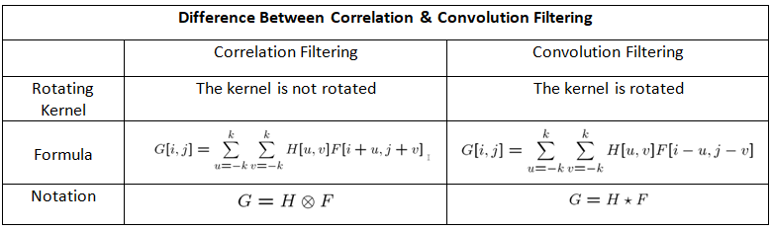

**Correlation** is a mathematical technique to see how close two things are related.

In image processing terms, it is used to compute the response of a mask on an image.

A mask is applied on a matrix from left to right.

Mask slides over the matrix from left to right by one unit every time.

Once the mask reaches the rightmost end, the mask is slid downward by one unit and again starts from left to right side.

The computed output is assigned to the central pixel, while neighbourhood pixels are also get used in the computation.

**The basic idea in correlation filtering**:

1. Slide the centre of the correlation kernel on the image
2. Multiply each weight in the correlation kernel by the pixel in the image
3. Sum these products

To give an example, let’s say we have 2 different matrices. One of them represents our image (F) and the other represents the kernel (H).

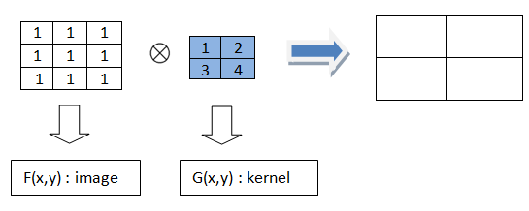

To find the output result, we start to follow our steps. We put the kernel on the image and after multiplying each weight in the kernel by the corresponding pixels, we sum the products. Slide the kernel and repeat the same steps.

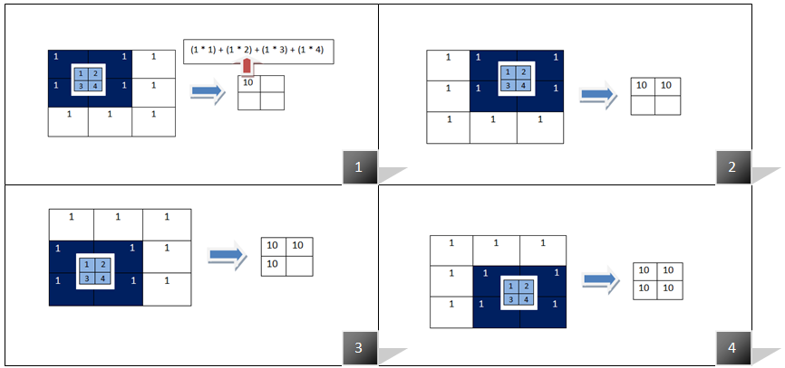

A convolution is also a mathematical tool that is used to **combine two things** in order to produce the result.

In image processing, convolution is a process by which we transform an input image by applying a kernel over it in a pixel-wise fashion.

When the convolution mask operates on a particular pixel, then it performs the action by considering that pixel and its neighbouring pixels and the result is returned to that one particular pixel.

Thus, we conclude that convolution in image processing is the mask operator.

### **How to perform convolution**

1. Flip the mask and do correlation.
2. The 1D mask is flipped horizontally, as there is a single row.
3. The 2D mask is flipped vertically and horizontally.
4. Mask is slid over the image matrix from the left to the right direction.
5. When the mask hovers on the image, corresponding elements of mask and image are multiplied and the products are added.
6. This process repeats for all the pixels of the image.

There are two types of operators in image processing.

* **Point operator:**While operating on a particular pixel, it takes only one pixel as input that is itself.  For example Brightness increasing operation. We increase each pixel’s intensity by the same value to increase the brightness of the image.
* **Mask operator:**While performing an action on a particular pixel it takes the particular pixel and its neighbouring pixels as the input. Convolution operation.

**Convolution Filtering**

The convolution filtering is also a linear filtering and it is more common then correlation filtering. There is a small difference between correlation and convolution :

1. Flip the filter in both dimensions (bottom to top, right to left)

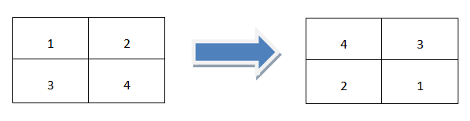

Flip the filter in both dimensions

2. Apply correlation filtering

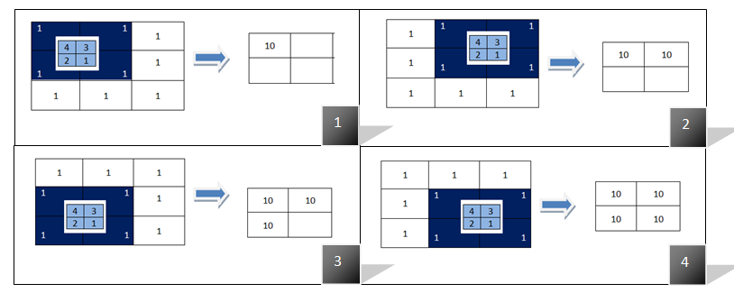

The second step which applying correlation filtering after flipping the kernel

But the code part is a bit different than the correlation filtering. Because there is nothing in opencv to make the convolution filtering directly. To make convolution filtering, there are 2 different way:

1. Flip the kernel in both dimensions in the code and then call filter2D function .
2. Use scipy library instead of opencv to make convolution filtering.

To compare the effects of the filters, let’s apply a random filter on the original image using correlation and convolution filtering.

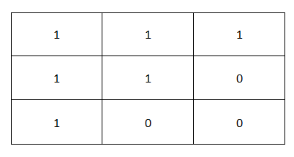

Randomly specified 3x3 filter

1. **Discuss the image smoothing filter with its model in the spatial domain. Also explain its significance in digital image processing.**

**Spatial Filtering** technique is used directly on pixels of an image.

Mask is usually considered to be added in size so that it has specific center pixel.

This mask is moved on the image such that the center of the mask traverses all image pixels.

**Classification on the basis of linearity:**  
There are two types:

**1.** Linear Spatial Filter

**2.** Non-linear Spatial Filter

**General Classification:**

**Smoothing Spatial Filter:**

Smoothing filter is used for blurring and noise reduction in the image.

Blurring is pre-processing steps for removal of small details and Noise Reduction is accomplished by blurring.

**Types of Smoothing Spatial Filter:**

**1.** Linear Filter (Mean Filter)

**2.** Order Statistics (Non-linear) filter

1. **Mean Filter:**  
   Linear spatial filter is simply the average of the pixels contained in the neighborhood of the filter mask.
   * The idea is replacing the value of every pixel in an image by the average of the grey levels in the neighborhood define by the filter mask.

**Types of Mean filter:**

* + **(i) Averaging filter:** It is used in reduction of the detail in image. All coefficients are equal.
  + **(ii) Weighted averaging filter:** In this, pixels are multiplied by different coefficients. Center pixel is multiplied by a higher value than average filter.

1. **Order Statistics Filter:**  
   It is based on the ordering the pixels contained in the image area encompassed by the filter. It replaces the value of the center pixel with the value determined by the ranking result. Edges are better preserved in this filtering.

**Types of Order statistics filter:**

* + **(i) Minimum filter:** 0th percentile filter is the minimum filter. The value of the center is replaced by the smallest value in the window.
  + **(ii) Maximum filter:** 100th percentile filter is the maximum filter. The value of the center is replaced by the largest value in the window.
  + **(iii) Median filter:** Each pixel in the image is considered. First neighboring pixels are sorted and original values of the pixel is replaced by the median of the list.

**Sharpening Spatial Filter:** It is also known as derivative filter. The purpose of the sharpening spatial filter is just the opposite of the smoothing spatial filter. Its main focus in on the removal of blurring and highlight the edges. It is based on the first and second order derivative.

**First order derivative:**

* Must be zero in flat segments.
* Must be non zero at the onset of a grey level step.
* Must be non zero along ramps.

1. **Explain the basic steps of filtering in frequency domain with a diagram.**

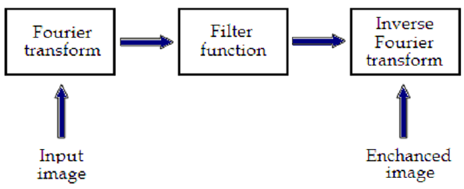

**Basics steps of frequency domain filtering**.

* The filtering in the spatial domain demands a filter mask (it is also referred as kernel or convolution filter).
* The filter mask is a matrix of odd usually size which is applied directly on the original data of the image.
* The mask is centred on each pixel of the initial image.
* For each position of the mask the pixel values of the image is multiplied by the corresponding values of the mask.
* The products of these multiplications are then added and the value of the central pixel of the original image is replaced by the sum.
* This must be repeated for every pixel in the image.
* The procedure is described schematically in Fig. 4. If the filter, by which the new pixel value was calculated, is a linear function of the entire pixel values in the filter mask (e.g. the sum of products), then the filter is called linear.
* If the output pixel is not a linear weighted combination of the input pixel of the image then the filtered is called non-linear.
* According to the range of frequencies they allow to pass through filters can be classified as low pass or high pass.
* Low pass filters allow the low frequencies to be retained unaltered and block the high frequencies.
* Low pass filtering removes noise and smooth the image but at the same time blur the image as it does not preserve the edges.
* High pass filters sharpness the edges of the image (areas in an image where the signal changes rapidly) and enhance object edge information.
* A severe disadvantage of high pass filtering is the amplification of statistical noise present in the measured counts.
* The next section is referred to three of the most common filters used by MatLab: the mean, median and Gaussian filter.

1. **Discuss the various image sharpening filters present in frequency domain**

**&**

1. **Discuss the various image smoothing filters present in frequency domain**

**Frequency Domain Filters** are used for smoothing and sharpening of image by removal of high or low frequency components.

Sometimes it is possible of removal of very high and very low frequency.

Frequency domain filters are different from spatial domain filters as it basically focuses on the frequency of the images.

It is basically done for two basic operation i.e., Smoothing and Sharpening

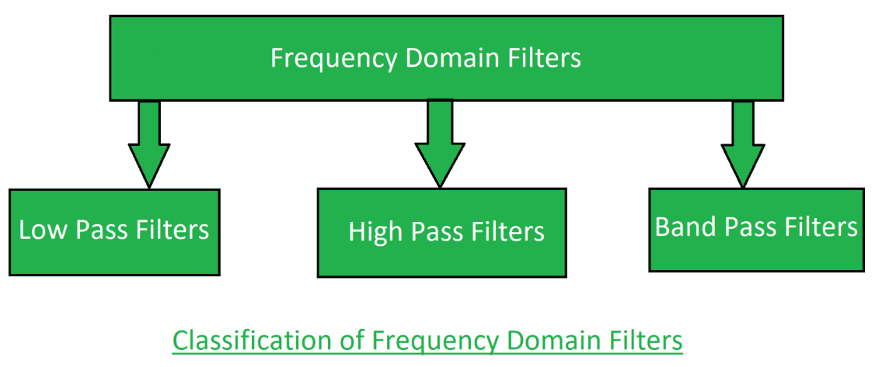

* 1. **Low pass filter:**  
     Low pass filter **removes the high frequency components** that means it keeps low frequency components.

It is used for smoothing the image.

It is used to smoothen the image by attenuating high frequency components and preserving low frequency components.  
Mechanism of low pass filtering in frequency domain is given by:

**G(u, v) = H(u, v) . F(u, v)**

where F(u, v) is the Fourier Transform of original image

and H(u, v) is the Fourier Transform of filtering mask

**2. High pass filter:**  
 High pass filter removes the low frequency components that means it keeps high frequency components.

It is used for sharpening the image.

It is used to sharpen the image by attenuating low frequency components and preserving high frequency components.  
Mechanism of high pass filtering in frequency domain is given by:

**H(u, v) = 1 - H'(u, v)**

where H(u, v) is the Fourier Transform of high pass filtering

and H'(u, v) is the Fourier Transform of low pass filtering

**3. Band pass filter:**  
Band pass filter removes the very low frequency and very high frequency components that means it keeps the moderate range band of frequencies. Band pass filtering is used to enhance edges while reducing the noise at the same time.

**9. Explain the usage of Homomorphic filtering in frequency domain.**

**Homomorphic Filtering**  
Homomorphic filters are widely used in image processing for compensating the effect of no uniform illumination in an image.

Pixel intensities in an image represent the light reflected from the corresponding points in the objects.

As per as image model, image f(z,y) may be characterized by two components:

(1) the amount of source light incident on the scene being viewed, and

(2) the amount of light reflected by the objects in the scene.

These portions of light are called the illumination and reflectance components, and are denoted i ( x , y) and r ( x , y) respectively

The functions i ( x , y) and r ( x , y) combine multiplicatively to give the image function

f ( x, y):  
 f ( x , y) = i ( x , y).r(x, y)   
 where 0 < i ( x , y ) < a and 0 < r( x , y ) < 1.

Homomorphic filters are used in such situations where the image is subjected to the  
multiplicative interference or noise as depicted in Eq. 1.

We cannot easily use the above product to operate separately on the frequency components of illumination and reflection because the Fourier transform of f ( x , y) is not separable

**Features & Application:**

1. Homomorphic filter is used for image enhancement.

2. It simultaneously normalizes the brightness across an image and increases contrast.

3. It is also used to remove multiplicative noise.

Images normally consist of light reflected from objects.

The basicnature of the image f(x,y) may be characterized by two components:

(1) The amount of source light incident on the scene being viewed, &

(2) The amount of light reflected by the objects in the scene

These portions of light are called the illumination and reflectance

components, and are denoted i(x,y) and r(x,y) respectively.

**10. Explain image degradation /restoration model with diagram.**

